Project Report Format
1. INTRODUCTION
1.1 Project Overview
Rising Waters is an AI-powered flood prediction and early warning system designed to reduce the impact of floods by providing timely and accurate predictions. The system collects weather, rainfall, river level, and historical flood data, processes it using machine learning algorithms, and predicts flood risk levels. It provides early alerts to citizens and disaster management authorities through a user-friendly web application, helping communities prepare and respond before disasters occur.
1.2 Purpose
The purpose of this project is to develop a reliable flood prediction platform that enables early detection of flood risks using artificial intelligence. The solution aims to improve disaster preparedness, reduce property damage, protect human lives, and support government agencies in making faster and more informed decisions during emergency situations.
2. IDEATION PHASE
2.1 Problem Statement
2.2 Empathy Map Canvas
2.3 Brainstorming
3. REQUIREMENT ANALYSIS
3.1 Customer Journey map
3.2 Solution Requirement
3.3 Data Flow Diagram
3.4 Technology Stack
4. PROJECT DESIGN
4.1 Problem Solution Fit
4.2 Proposed Solution
4.3 Solution Architecture
5. PROJECT PLANNING & SCHEDULING
5.1 Project Planning
6. FUNCTIONAL AND PERFORMANCE TESTING
6.1 Performance Testing
7. RESULTS
7.1 Output Screenshots
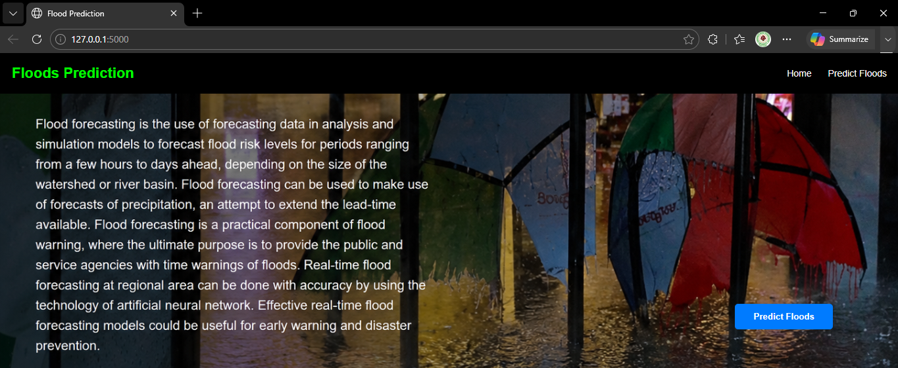
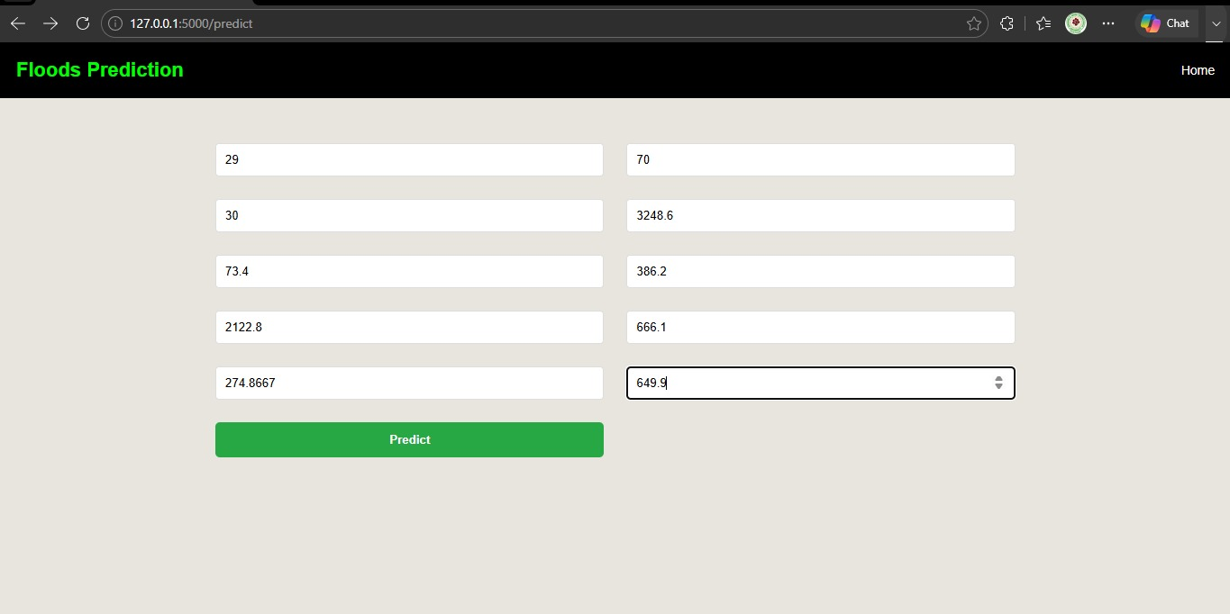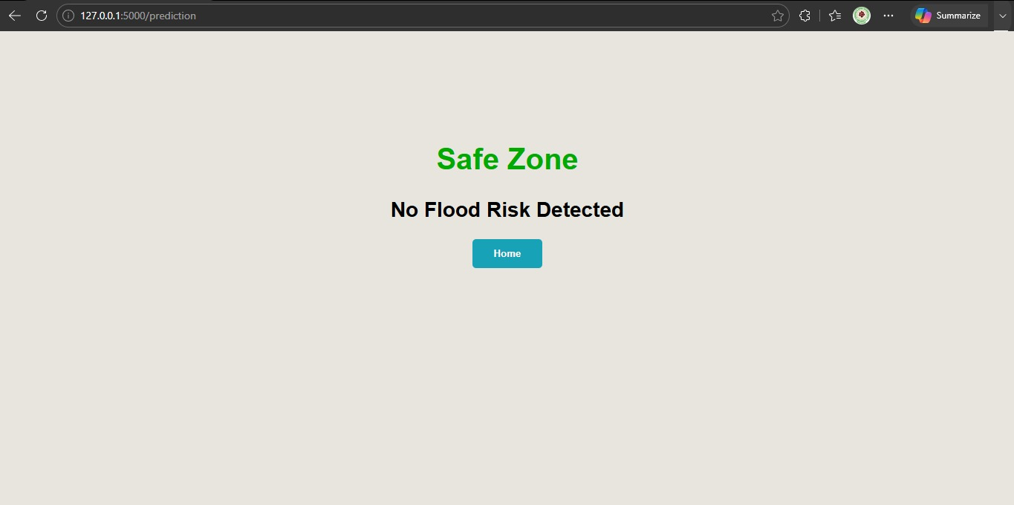

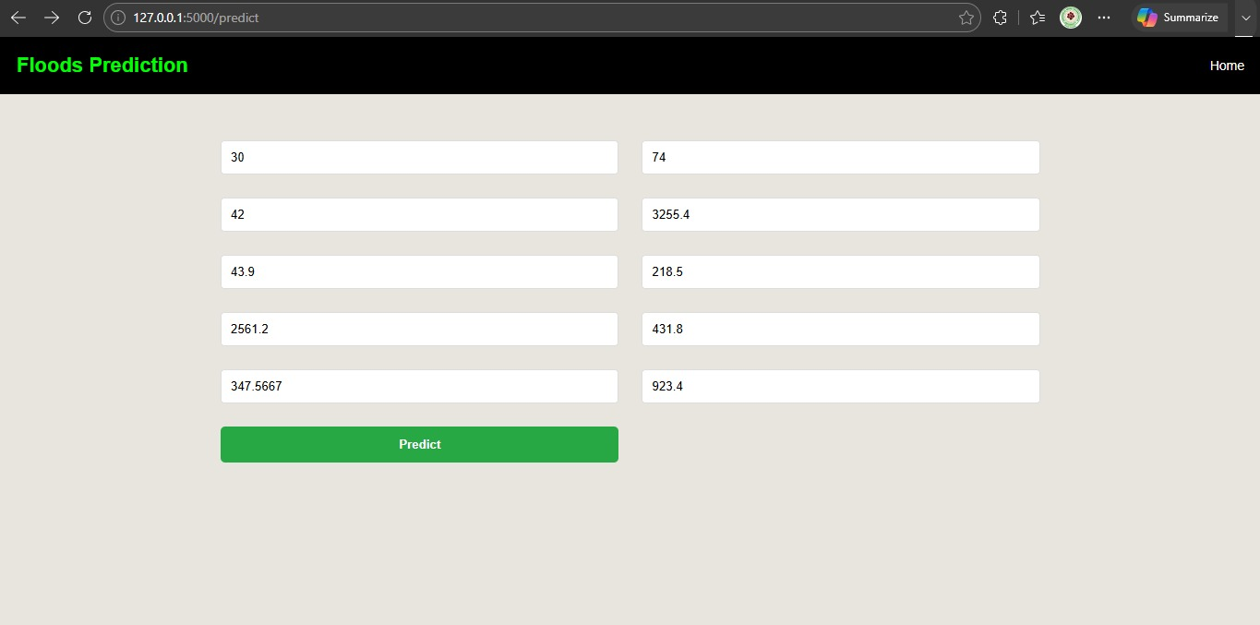
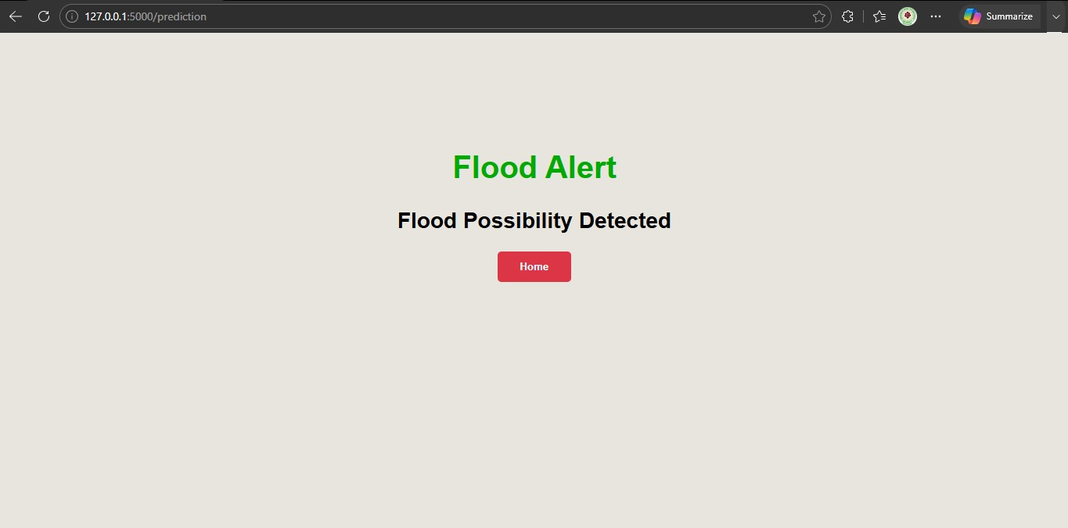
8. ADVANTAGES & DISADVANTAGES

Advantages | Disadvantages
Provides early flood prediction using machine learning techniques. | Prediction accuracy depends on the quality and availability of input data.
Improves disaster preparedness through timely alerts and warnings. | Extreme or unexpected weather conditions may reduce prediction accuracy.
Helps government agencies make informed emergency response decisions. | Requires continuous internet connectivity for accessing real-time weather data.
Reduces potential loss of life and property by enabling proactive measures. | Machine learning models require periodic retraining with updated datasets.
Uses real-time weather and environmental data for accurate predictions. | Initial deployment and maintenance costs may be high.

9. CONCLUSION
Rising Waters addresses the increasing challenges posed by floods through an intelligent, data-driven flood prediction and early warning system. By utilizing machine learning algorithms along with real-time weather and environmental data, the project provides accurate flood risk predictions that enable authorities and communities to take timely preventive actions. The system improves disaster preparedness, supports informed decision-making, and contributes to reducing the loss of life, property, and environmental damage. Overall, Rising Waters demonstrates how artificial intelligence and predictive analytics can be effectively applied to build smarter, safer, and more resilient communities in the face of climate-related disasters.

10. FUTURE SCOPE
- Integrate IoT-based water level and river flow sensors for real-time monitoring.
- Improve prediction accuracy using advanced Deep Learning models such as LSTM and Transformer networks.
- Develop Android and iOS mobile applications for instant flood alerts.
- Incorporate satellite imagery and GIS mapping for more precise flood forecasting.
- Enable multilingual notifications to reach diverse communities.
- Integrate SMS, WhatsApp, and emergency communication services for faster alert dissemination.
- Collaborate with government disaster management agencies for real-world implementation.
- Continuously update the machine learning model using new historical and real-time datasets to enhance prediction performance.

11. APPENDIX
  - Dataset Link
https://www.kaggle.com/datasets/arbethi/rainfall-dataset
  - GitHub & Project Demo Link
    - GitHub Link
ttps://github.com/MMBhaveshHRK/Rising-Waters
    - Project Demo Link
https://drive.google.com/file/d/1aQnuVJNWRrYiBFr3g0DRYWbMgAsr_m96/view?usp=drive_link

